**Summer Internship report**

on

# **“Transformation of Handwritten sketches into HTML prototypes”**

**Submitted by**

Posi Sai Venkata Rohith Yerra, EE19B048

**Under the guidance of**

Rajnish Kumar**(NOT SURE)**

(V-Executive Manager, IT Architecture, Deloitte USI)

**Submitted to**

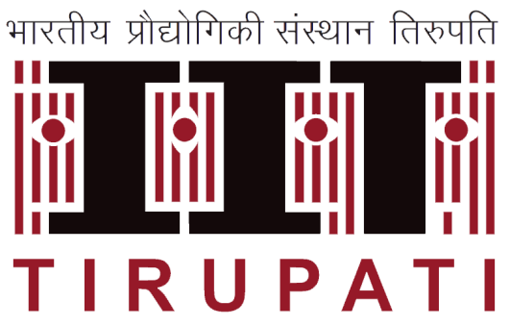

**DEPARTMENT OF ELECTRICAL ENGINEERING**

**INDIAN INSTITUTE OF TECHNOLOGY TIRUPATI**

**23rd May 2022 – 15th JULY 2022**

# **ABSTRACT**

Typically, during the UI development, creative designers or business users of the application hand draw their UI design ideas on a whiteboard, or a graphic tablet, or even a piece of paper. Later, they use the wireframing tools on a computer to create the exact design again which is a redundant step. Implementing GUI code is, however, time-consuming and prevent developers from dedicating the majority of their time implementing the actual functionality and logic of the software they are building. Given this situation, an Artificial Intelligence based UI development tool that converts hand-drawn UI sketches to a working HTML prototype could save a lot of time, effort, and money.

In this project, we have worked on building a tool (web application) that uses AI to transform a handwritten user interface design from a picture/snapshot to a valid HTML markup code. The project also focuses on making the HTML file downloadable thus, allowing the users to edit the resultant HTML code.

# **ACKNOWLEDGEMENT**

I am grateful to Mr. Pushpak Kumar, Placement officer-IIT Tirupati, Dr. Prasanth Vooka, Internship Faculty Advisor, Department of Electrical Engineering, IIT Tirupati and the Career Development Cell, IIT Tirupati for providing me the opportunity and support to complete my summer internship in Deloitte USI, Hyderabad.

I would like to thank my mentors in Deloitte, Rajnish Kumar(V-Exec Manager, IT Architecture), Avik Basu() and Sheeba Abhilash() for their continuous support and guidance throughout the internship. I would also like to thank Mr. Bharat Bhusham and Mr. Phani Dhamaraju for their constructive criticism on the project.

Finally, I would like to thank my fellow interns who, with their patience and openness created an enjoyable working environment. It is indeed with a great sense of pleasure and immense sense of gratitude that I acknowledge the help of these individuals.

Sincerely

Posi Sai Venkata Rohith Yerra

# **INTERNSHIP COMPLETION CERTIFICATE**

# **ABOUT INDUSTRY**

* **Deloitte**

Deloitte is a leading global provider of audit and assurance, consulting, financial advisory, risk advisory, tax, and related services. With more than 150 years of hard work and commitment to making a real difference, the organization has grown in scale and diversity—approximately 286,000 people in 150 countries and territories, providing these services—yet our shared culture remains the same. Deloitte serves four out of five Fortune Global 500® companies.

* **Deloitte Application Studios**

In Deloitte Application studios around the world, the team combines cutting-edge creativity with trusted business and technology experience to define and deliver digital experiences for the world’s leading brands. The principal focus of this team is the development and management of technology solutions that enable Functions, Businesses, and Member Firm Information Systems

* **The Spark Program**

Spark is an internship program specifically designed for University students to get industrial exposure. As an Intern and as part of the internship, interns will be engaged in working on cutting-edge technologies, innovations, research, thought leadership whitepapers, and recommending quality solutions for the applications built on varied technologies like AI, Data Science, RPA, Microsoft Azure, Salesforce, SAP, Java, and Service Desk / Service Now. Interns will support the development of quick short-term projects which provide high-quality solutions and great business value to the customers by following a streamlined system development methodology.



# **TABLE OF CONTENTS**